Exercise 1

1. Please develop a course timetable as follows:

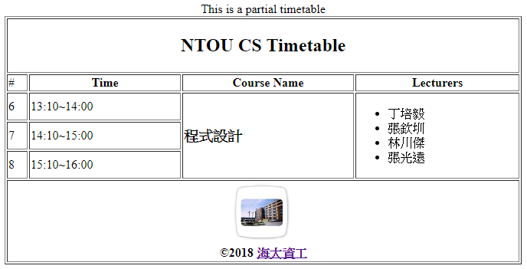

Requirements:

1. The width of the table is 50% of the screen width.
2. "NTOU CS Timetable" is an h2 heading.
3. "程式設計" is an h3 heading.
4. A small-sized image (80\*80) ntoucs.jpg is placed in the foot of the table.
5. The user can click the image to link to the website of "海大資工". (<http://www.cs.ntou.edu.tw>)
6. The user can click the "海大資工" text to link to the Google search results for "海大資工" in a new window (瀏覽器分頁).

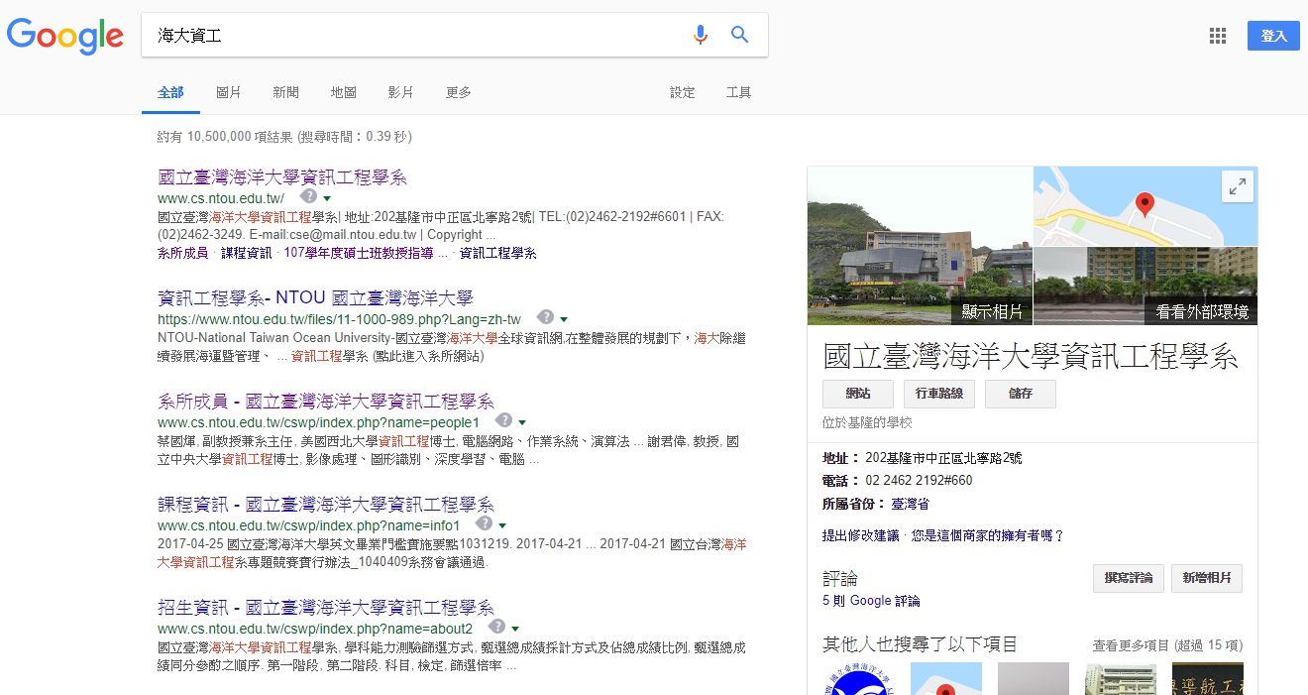

Hints:

1. Understand the structure of a table.
2. Understand how to use rowspan and colspan in a table.
3. Understand how to use list.
4. Understand how to make an image hyperlink.
5. Understand how to make a single line break (斷行).
6. Understand how to display special characters (©).
7. Google the way to show a URL in a new window.
8. Please write a HTML form as follows:

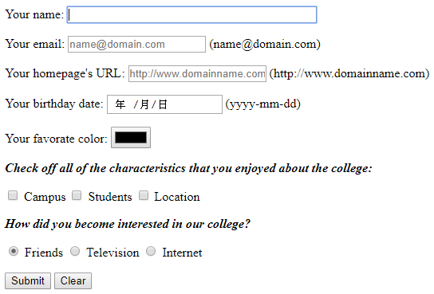

Requirements：

* Name:
  + 滑鼠指標需落在「Your name」的輸入欄位中。
  + name屬性設定為"fullname"。
* E-mail與Homepage:
  + Email若不填寫，使用者按下submit後會出現強制輸入之訊息。
  + 若E-mail填寫錯誤的格式，使用者按下submit後會出現提示訊息。
  + name屬性設定為"email"。
* Homepage:
  + 若Homepage填寫不對的URL (例如少了http)，使用者按下submit後會出現提示訊息。
  + name屬性設定為"url"。
* Birthday:
  + 可透過選取設定或直接輸入數字。
  + name屬性設定為"date"。
* Color:
  + 點選顏色區塊會出現color選擇器。
  + name屬性設定為"color"。
* Likes/Interest:
  + 單選與多選選項請按照題目要求設計，而使用者不論點選該選項之文字或checked box/radio button之按鈕，都可以選取該選項。
  + 多選題的name屬性設定為"likes"。
  + 單選題的name屬性設定為"interest"。
* 整張表單要以get method送到http://140.121.197.131:7602/showForm.jsp，理論上應該出現類似底下的畫面：

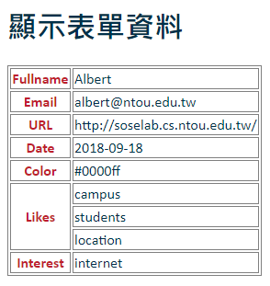

Hints:

* Understand various types of HTML input elements.
* Understand the "action" attribute of <form> element.
* Use <label> to group the text and its <input> element.